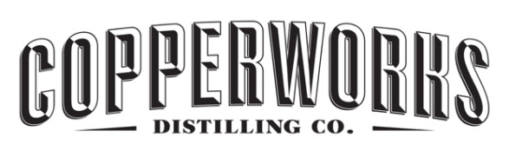

Copperworks American Single Malt Whiskey
Single Cask #7-2 – June 14, 2023
Brew Data
Brews contributing to Cask #7-2
- Brew 1 number: 2016-3-25-1 (FV2)
  - Brew date: 3/25/16
  - Malt Bill:
    - GWM Pale 4000 lbs,
    - Cara 35 605 lbs,
    - Special B 192.5 lbs,
    - Special X 192.5 lbs,
    - Victory 350 lbs,
    - Melanoidin 200 lbs
  - Yeast Source: Elysian Brewing
  - Brewery: Elysian Brewing
  - Volume in fermentation: 1867 gal
  - Original Gravity: 1.07064
  - Terminal Gravity: 1.014
  - Days in fermentation: 19 days at 78 degrees F.
  - Percent ABV at end of fermentation: 7.81
  - Minimum days in cold-conditioning: 22 days
- Brew 2 number: 2016-04-22-1 (FV3)
  - Brew date: 4/22/2016
  - Malt Bill:
    - GWM Pale 4000 lbs,
    - Cara 35 605 lbs,
    - Special B 192.5 lbs,
    - Special X 192.5 lbs,
    - Victory 350 lbs,
    - Melanoidin 200 lbs
  - Yeast Source: Elysian Brewing
  - Brewery: Elysian Brewing
  - Volume in fermentation: 1923 gal
  - Original Gravity: 1.07502
  - Terminal Gravity: 1.0157
  - Days in fermentation: 15 days at 78 degrees F.
  - Percent ABV at end of fermentation: 8.25
  - Minimum days in cold-conditioning: 10 days
Distillation Data
Total # of Wash Distillations:
  - Wash Distillation 1 number: 20160503-1
    - Low Wines Yield: 322.71 gal
    - Low Wines ABV: 21.5
  - Wash Distillation 2 number: 20160510-1
    - Low Wines Yield: 319.45 gal
    - Low Wines ABV: 21.5
  - Wash Distillation 3 number: 20160516-1
    - Low Wines Yield: 333.58 gal
    - Low Wines ABV: 22.1%

Total # of Whiskey Distillations: 3
  - Whiskey Distillation 1 number: 20160505-1
    - New make yield: 113.09 gal
    - New make ABV: 67.8
  - Whiskey Distillation 2 number: 20160512-1
    - New make yield: 114.19 gal
    - New make ABV: 67.75
  - Whiskey Distillation 3 number: 20160518-1
    - New make yield: 106.51 gal
    - New make ABV: 67.8

Maturation Data
- Barreling date: 07/05/2016
- Proofing date for New Make Whiskey: 07/05/2016
- Barrel entry proof: 115 Proof (57.5% ABV)
  - Cooperage: Independent Stave Company – Lebanon, Kentucky
  - First Use: Copperworks Pale Malt – 807 days
  - Barrel fill volume in gallons: 52.56
  - Stave wood: American White Oak
  - Char: #3
- Warehouse conditions: ~70 degrees F. Average humidity ~50%
- Days of maturing, prior to emptying: 2540 days
- Exit volumes and proof: 36.68 gallons @ 131.2 proof
Bottling Data
- Date Bottled: 6/7/23
- Bottling Proof: 131.2 proof
- Bottles filled for release: 180

